**Baza e te dhenave per nje dyqan online *(e-mobile)***

1. **Koncepti I ER Diagram-it**

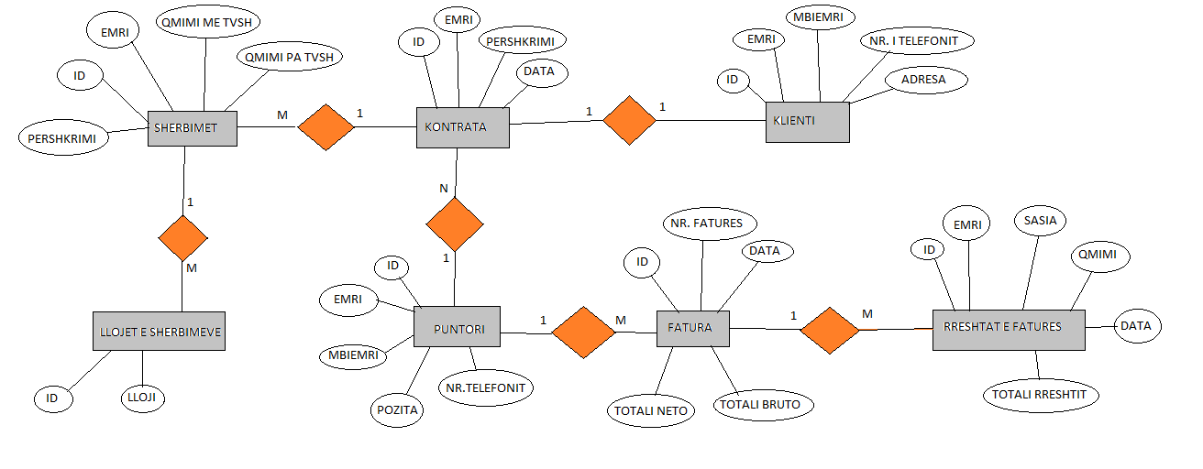

1. **Implementimi I ER Diagram-it ne MySQL Workbench**

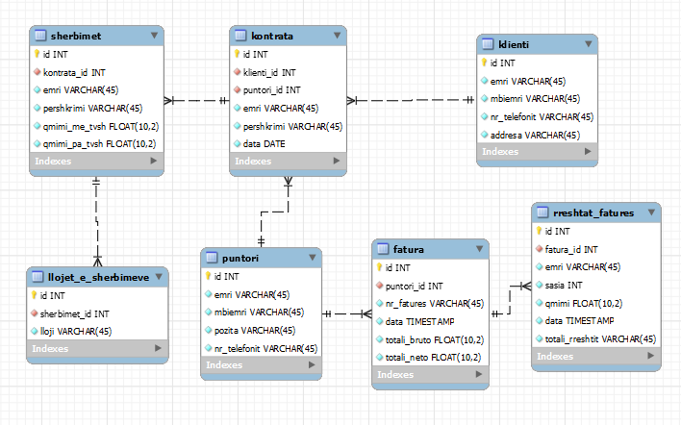

DROP TABLE IF EXISTS `fatura`;

/*!40101 SET @saved_cs_client     = @@character_set_client */;

/*!50503 SET character_set_client = utf8mb4 */;

CREATE TABLE `fatura` (

  `id` int NOT NULL AUTO_INCREMENT,

  `puntori_id` int NOT NULL,

  `nr_fatures` varchar(45) NOT NULL,

  `data` timestamp NOT NULL DEFAULT CURRENT_TIMESTAMP,

  `totali_bruto` float(10,2) NOT NULL,

  `totali_neto` float(10,2) NOT NULL,

  PRIMARY KEY (`id`),

  KEY `fatura_puntori_id_fk_idx` (`puntori_id`),

  CONSTRAINT `fatura_puntori_id_fk` FOREIGN KEY (`puntori_id`) REFERENCES `puntori` (`id`) ON DELETE CASCADE ON UPDATE CASCADE

) ENGINE=InnoDB AUTO_INCREMENT=6 DEFAULT CHARSET=utf8mb4 COLLATE=utf8mb4_0900_ai_ci;

/*!40101 SET character_set_client = @saved_cs_client */;

LOCK TABLES `fatura` WRITE;

/*!40000 ALTER TABLE `fatura` DISABLE KEYS */;

/*!40000 ALTER TABLE `fatura` ENABLE KEYS */;

UNLOCK TABLES;

DROP TABLE IF EXISTS `klienti`;

/*!40101 SET @saved_cs_client     = @@character_set_client */;

/*!50503 SET character_set_client = utf8mb4 */;

CREATE TABLE `klienti` (

  `id` int NOT NULL AUTO_INCREMENT,

  `emri` varchar(45) NOT NULL,

  `mbiemri` varchar(45) NOT NULL,

  `nr_telefonit` varchar(45) NOT NULL,

  `addresa` varchar(45) NOT NULL,

  PRIMARY KEY (`id`)

) ENGINE=InnoDB AUTO_INCREMENT=4 DEFAULT CHARSET=utf8mb4 COLLATE=utf8mb4_0900_ai_ci;

/*!40101 SET character_set_client = @saved_cs_client */;

LOCK TABLES `klienti` WRITE;

/*!40000 ALTER TABLE `klienti` DISABLE KEYS */;

/*!40000 ALTER TABLE `klienti` ENABLE KEYS */;

UNLOCK TABLES;

DROP TABLE IF EXISTS `kontrata`;

/*!40101 SET @saved_cs_client     = @@character_set_client */;

/*!50503 SET character_set_client = utf8mb4 */;

CREATE TABLE `kontrata` (

  `id` int NOT NULL AUTO_INCREMENT,

  `klienti_id` int NOT NULL,

  `puntori_id` int NOT NULL,

  `emri` varchar(45) NOT NULL,

  `pershkrimi` varchar(45) NOT NULL,

  `data` date NOT NULL,

  PRIMARY KEY (`id`),

  KEY `kontrata_puntori_id_fk_idx` (`puntori_id`),

  KEY `kontrata_klienti_id_fk_idx` (`klienti_id`),

  CONSTRAINT `kontrata_klienti_id_fk` FOREIGN KEY (`klienti_id`) REFERENCES `klienti` (`id`) ON DELETE CASCADE ON UPDATE CASCADE,

  CONSTRAINT `kontrata_puntori_id_fk` FOREIGN KEY (`puntori_id`) REFERENCES `puntori` (`id`) ON DELETE CASCADE ON UPDATE CASCADE

) ENGINE=InnoDB AUTO_INCREMENT=8 DEFAULT CHARSET=utf8mb4 COLLATE=utf8mb4_0900_ai_ci;

/*!40101 SET character_set_client = @saved_cs_client */;

LOCK TABLES `kontrata` WRITE;

/*!40000 ALTER TABLE `kontrata` DISABLE KEYS */;

/*!40000 ALTER TABLE `kontrata` ENABLE KEYS */;

UNLOCK TABLES;

DROP TABLE IF EXISTS `llojet_e_sherbimeve`;

/*!40101 SET @saved_cs_client     = @@character_set_client */;

/*!50503 SET character_set_client = utf8mb4 */;

CREATE TABLE `llojet_e_sherbimeve` (

  `id` int NOT NULL AUTO_INCREMENT,

  `sherbimet_id` int NOT NULL,

  `lloji` varchar(45) NOT NULL,

  PRIMARY KEY (`id`),

  KEY `llojet_e_sherbimeve_sherbimet_id_fk_idx` (`sherbimet_id`),

  CONSTRAINT `llojet_e_sherbimeve_sherbimet_id_fk` FOREIGN KEY (`sherbimet_id`) REFERENCES `sherbimet` (`id`) ON DELETE CASCADE ON UPDATE CASCADE

) ENGINE=InnoDB AUTO_INCREMENT=6 DEFAULT CHARSET=utf8mb4 COLLATE=utf8mb4_0900_ai_ci;

/*!40101 SET character_set_client = @saved_cs_client */;

LOCK TABLES `llojet_e_sherbimeve` WRITE;

/*!40000 ALTER TABLE `llojet_e_sherbimeve` DISABLE KEYS */;

/*!40000 ALTER TABLE `llojet_e_sherbimeve` ENABLE KEYS */;

UNLOCK TABLES;

DROP TABLE IF EXISTS `puntori`;

/*!40101 SET @saved_cs_client     = @@character_set_client */;

/*!50503 SET character_set_client = utf8mb4 */;

CREATE TABLE `puntori` (

  `id` int NOT NULL AUTO_INCREMENT,

  `emri` varchar(45) NOT NULL,

  `mbiemri` varchar(45) NOT NULL,

  `pozita` varchar(45) NOT NULL,

  `nr_telefonit` varchar(45) NOT NULL,

  PRIMARY KEY (`id`)

) ENGINE=InnoDB AUTO_INCREMENT=4 DEFAULT CHARSET=utf8mb4 COLLATE=utf8mb4_0900_ai_ci;

/*!40101 SET character_set_client = @saved_cs_client */;

LOCK TABLES `puntori` WRITE;

/*!40000 ALTER TABLE `puntori` DISABLE KEYS */;

/*!40000 ALTER TABLE `puntori` ENABLE KEYS */;

UNLOCK TABLES;

DROP TABLE IF EXISTS `rreshtat_fatures`;

/*!40101 SET @saved_cs_client     = @@character_set_client */;

/*!50503 SET character_set_client = utf8mb4 */;

CREATE TABLE `rreshtat_fatures` (

  `id` int NOT NULL AUTO_INCREMENT,

  `fatura_id` int NOT NULL,

  `emri` varchar(45) NOT NULL,

  `sasia` int NOT NULL,

  `qmimi` float(10,2) NOT NULL,

  `data` timestamp NOT NULL DEFAULT CURRENT_TIMESTAMP,

  `totali_rreshtit` varchar(45) NOT NULL,

  PRIMARY KEY (`id`),

  KEY `rreshtat_fatures_fatura_id_fk_idx` (`fatura_id`),

  CONSTRAINT `rreshtat_fatures_fatura_id_fk` FOREIGN KEY (`fatura_id`) REFERENCES `fatura` (`id`) ON DELETE CASCADE ON UPDATE CASCADE

) ENGINE=InnoDB AUTO_INCREMENT=4 DEFAULT CHARSET=utf8mb4 COLLATE=utf8mb4_0900_ai_ci;

/*!40101 SET character_set_client = @saved_cs_client */;

LOCK TABLES `rreshtat_fatures` WRITE;

/*!40000 ALTER TABLE `rreshtat_fatures` DISABLE KEYS */;

/*!40000 ALTER TABLE `rreshtat_fatures` ENABLE KEYS */;

UNLOCK TABLES;

DROP TABLE IF EXISTS `sherbimet`;

/*!40101 SET @saved_cs_client     = @@character_set_client */;

/*!50503 SET character_set_client = utf8mb4 */;

CREATE TABLE `sherbimet` (

  `id` int NOT NULL AUTO_INCREMENT,

  `kontrata_id` int NOT NULL,

  `emri` varchar(45) NOT NULL,

  `pershkrimi` varchar(45) NOT NULL,

  `qmimi_me_tvsh` float(10,2) NOT NULL,

  `qmimi_pa_tvsh` float(10,2) NOT NULL,

  PRIMARY KEY (`id`),

  KEY `sherbimet_kontrata_id_fk_idx` (`kontrata_id`),

  CONSTRAINT `sherbimet_kontrata_id_fk` FOREIGN KEY (`kontrata_id`) REFERENCES `kontrata` (`id`) ON DELETE CASCADE ON UPDATE CASCADE

) ENGINE=InnoDB AUTO_INCREMENT=8 DEFAULT CHARSET=utf8mb4 COLLATE=utf8mb4_0900_ai_ci;

/*!40101 SET character_set_client = @saved_cs_client */;

LOCK TABLES `sherbimet` WRITE;

/*!40000 ALTER TABLE `sherbimet` DISABLE KEYS */;

/*!40000 ALTER TABLE `sherbimet` ENABLE KEYS */;

UNLOCK TABLES;

/*!40103 SET TIME_ZONE=@OLD_TIME_ZONE */;

**3.Populimi I tabelave me te dhena**

I mbushim tabelat me te dhena perkatese – ne menyre qe te marrim rezultate nga pyetesoret.

INSERT INTO `fatura` VALUES (3,2,'3','2022-09-15 09:40:25',4.20,5.00),(4,1,'2','2019-10-25 03:05:40',3.15,3.95),(5,3,'1','2021-12-28 23:00:00',15.00,14.20);

INSERT INTO `klienti` VALUES (1,'Lindmir','Berisha','049322122','prizren'),(2,'Arben','Hoxha','044100200','prishtine'),(3,'Blerim','Gashi','044222111','gjakove');

INSERT INTO `kontrata` VALUES (4,1,2,'Kontrat Individuale','Kontrate per sherbime te telefonise mobile','2022-09-15'),(5,3,1,'Kontrat Biznesi','Kontrate per sherbime te Internetit 4G','2021-12-01'),(6,2,3,'Kontrat Biznesi\'','Kontrate per sherbime te Internetit 4G','2019-04-15');

INSERT INTO `llojet_e_sherbimeve` VALUES (1,1,'Internet | HD SPORT'),(2,2,'Internet | HD TV'),(3,4,'Kapllovik'),(4,3,'Internet');

INSERT INTO `puntori` VALUES (1,'hysen','gashi','IT','044100200'),(2,'besnik','thaqi','Programer','044255341'),(3,'endrit','hoxha','IT','049415613');

INSERT INTO `rreshtat_fatures` VALUES (1,3,'Internet per telefon mobil',1,4.99,'2022-12-09 23:00:00','4.99'),(2,4,'Internet per biznes',1,14.99,'2021-09-14 22:00:00','14.99');

INSERT INTO `sherbimet` VALUES (1,4,'Internet per telefon mobil','I vlefshem per 1 muaj',4.99,4.09),(2,5,'Internet per biznes','I vlefshem per 1 muaj',14.99,12.29),(3,6,'Familjare Pro','I vlefshem per 1 muaj',24.50,23.00),(4,4,'Pako Baze','I vlefshem per 1 muaj',14.99,12.29);

1. **MySQL petesoret(queries)**

**-- select * from `e-mobile`.fatura where nr_fatures >=3;**

**-- select emri from `e-mobile`.puntori ;**

**-- select emri from `e-mobile`.puntori where emri="avni" ;**

**-- select * from `e-mobile`.llojet_e_sherbimeve where lloji="DATA";**

**-- select * from `e-mobile`.llojet_e_sherbimeve;**

**-- select * from `e-mobile`.rreshtat_fatures where qmimi between 3 and 5;**

**-- select * from `e-mobile`.sherbimet where emri like '%internet%';**

**-- select * from `e-mobile`.fatura where data like '2022-09-15%';**

**-- select * from `e-mobile`.fatura order by totali_bruto desc;**

**-- select * from `e-mobile`.fatura where totali_bruto > 4 order by totali_neto desc;**

**-- select avg(totali_bruto) as 'qmimi mesatar' from `e-mobile`.fatura;**

**-- select * from `e-mobile`.fatura where totali_bruto >(select avg(totali_bruto) from `e-mobile`.fatura);**

**-- into `e-mobile`.puntori (id, emri, mbiemri, pozita, nr_telefonit) values(4,'insert', 'into', 'shef', 0444444);**

**-- update `e-mobile`.puntori set nr_telefonit=044100200 where `e-mobile`.puntori.emri like 'insert%';**

**-- delete from `e-mobile`.puntori where pozita = 'shef';**

**-- select * from `e-mobile`.fatura inner join `e-mobile`.puntori on `e-mobile`.fatura.puntori_id = `e-mobile`.puntori.id where `e-mobile`.puntori.id =3;**

**-- select emriplot(emri, pozita) from puntori;**